Objectives:

* Introduction to Methods

Methods are used to break down programs to simply them, this term is called **code reuse** because you are writing the code and reusing it later

The **void** method is used to terminate the program after it is executed

Public static void, the **public** means it can be used outside of its own class

Once methods are created you have the capability in calling them

**There are 9 projects each worth 11.1%**

**Project #1**

Create a class and type in the following code below

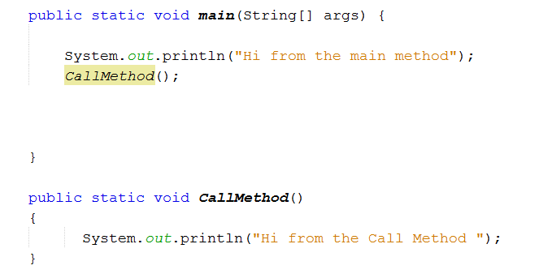

Note here we are calling the CallMethod inside the main method.

Run the program to test it.

**#1 print screen the output with code below here.**

**Project #2**

Now call the CallMethod 5x using a For Loop

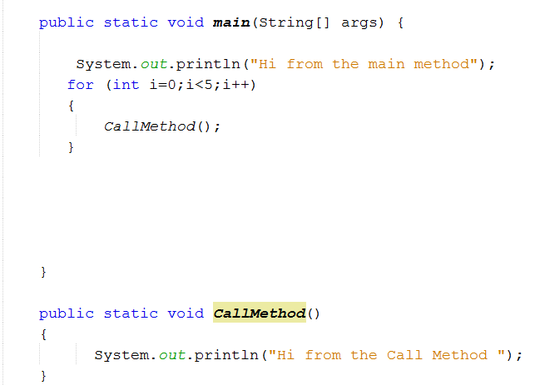

Run the program to test it.

**#2 print screen the output with code below here.**

**Project #2**

Calling two methods, this is called **Hierarchical methods**

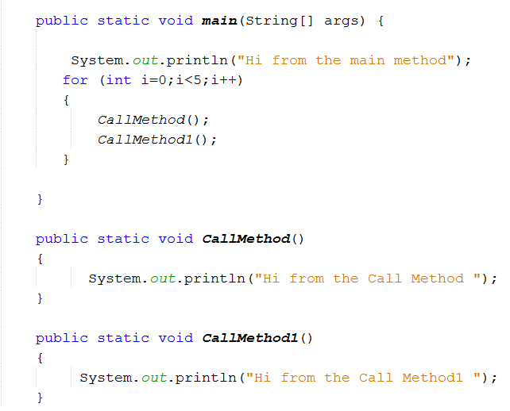

Run the program to test it.

**#3 print screen the output with code below here.**

**Project #4**

Create a new class and name it PassingMultipleArgs

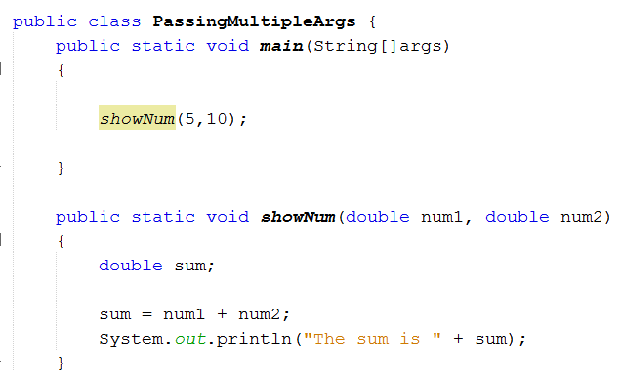

Notice, since we are passing multiple arguments when we call the method we must assign what we want to pass which in our case is *showNum(5,10);*

**#4 print screen the output with code below here.**

**Project #5**

Passing String values

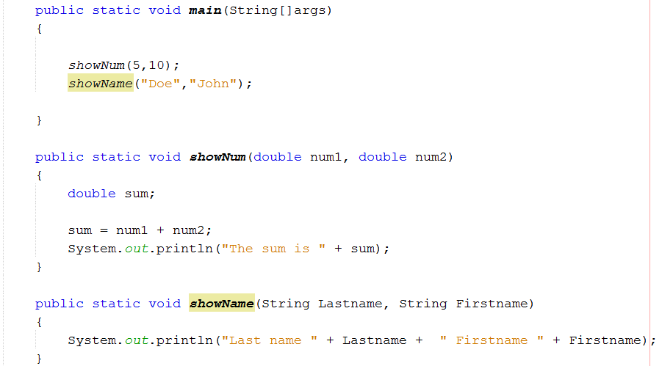

**#5 print screen the output with code below here.**

**Project #6**

Passing String and Integer values

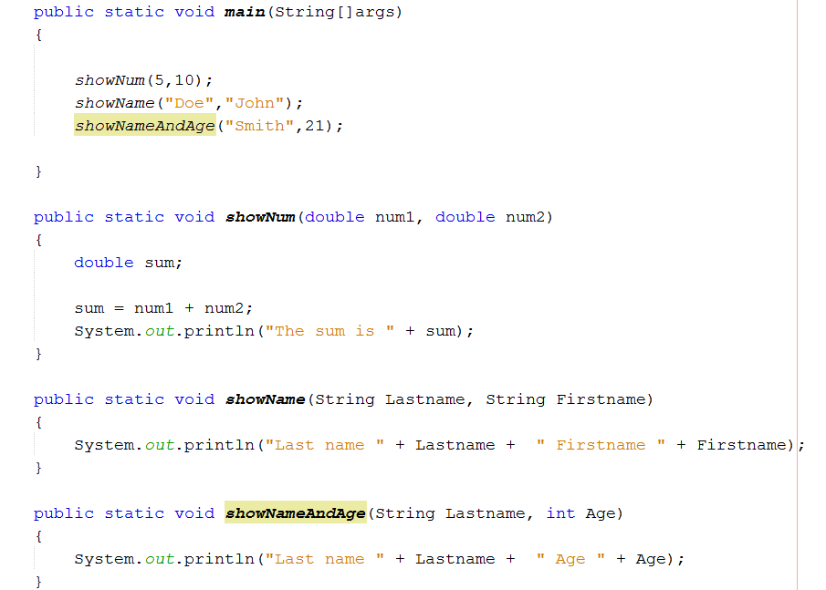

**#6 print screen the output with code below here.**

**Project #7**

Returning a number for a method and passing 1 argument

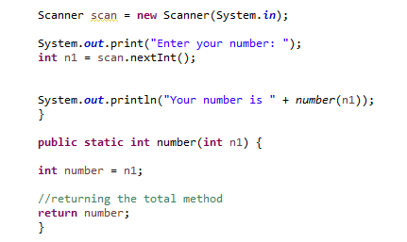

Note: when you use INT or double you must use the return type (Page 294 figure 5-14), for a VOID you do not have to use the return method

**#7 print screen the output with code below here.**

**Project #8**

Returning a number for a method and passing 2 arguments

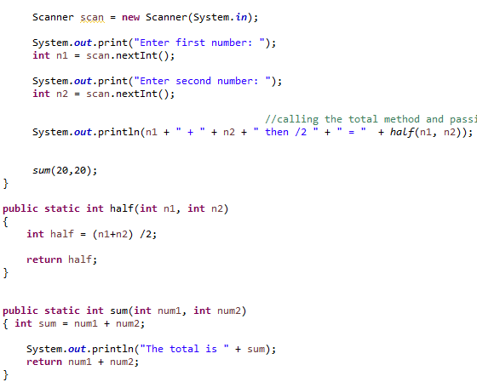

**#8 print screen the output with code below here.**

**Project #9**

Passing Input values and calling the method

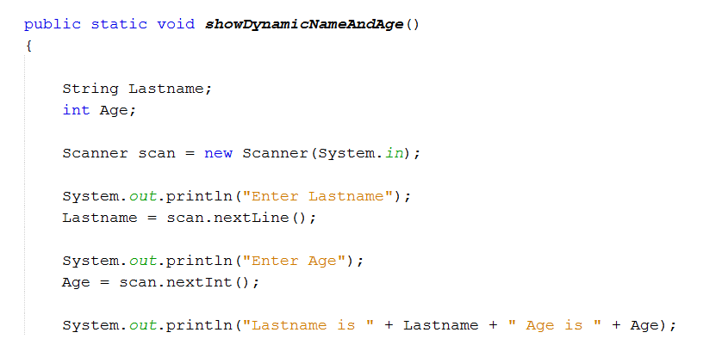

Calling the showDynamicNameAndAge method

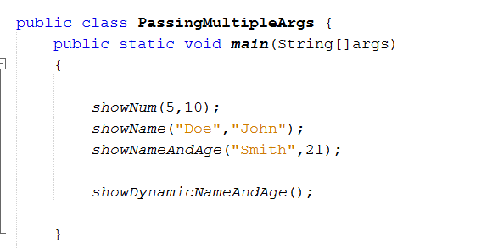

**#9 print screen the output with code below here.**

**Submit this document to Module 4 Class Exercise #4**